Graphing In Systat 13
Basic Statistics
Open RAD_GROW, a textbook dataset (Samuels & Witmer 1999) of radish seedling growth in light and darkness.

Analyze → Basic Statistics…Add → RAD_GROW_D RAD_GROW_L
alternatively
Data → By Groups…Add → TREAT$
Analysis → Descriptive Statistics → Basic Statistics…Add → RAD_GROW

If you need to generate a data file of these statistics
Data → By Groups…Add → TREAT$
Analyze → Basic Statistics…Add → RAD_GROW, then Save statistics, toggle “Aggregate”. Name data file to be saved. Now open the data file and see what it looks like.

 | RAD_GROW_L | RAD_GROW_D
N of Cases | 14 | 14
Minimum | 4.000 | 8.000
Maximum | 27.000 | 37.000
Arithmetic Mean | 16.357 | 22.143
Standard Deviation | 6.801 | 9.623
▼Descriptive Statistics
 | RAD_GROW_D
N of Cases | 14
Minimum | 8.000
Maximum | 37.000
Arithmetic Mean | 22.143
Standard Deviation | 9.623
▼Descriptive Statistics
Results for TREAT$ = DARK

 | RAD_GROW
N of Cases | 14
Minimum | 8.000
Maximum | 37.000
Arithmetic Mean | 22.143
Standard Deviation | 9.623

Results for TREAT$ = LIGHT

 | RAD_GROW
N of Cases | 14
Minimum | 4.000
Maximum | 27.000
Arithmetic Mean | 16.357
Standard Deviation | 6.801
▼Descriptive Statistics
Results for TREAT$ = DARK

 | RAD_GROW
N of Cases | 14
Minimum | 8.000
Maximum | 37.000
Arithmetic Mean | 22.143
Standard Deviation | 9.623

Results for TREAT$ = LIGHT

 | RAD_GROW
N of Cases | 14
Minimum | 4.000
Maximum | 27.000
Arithmetic Mean | 16.357
Standard Deviation | 6.801

Statistics have been saved.
▼File: C:\Users\Lab User\Desktop\radishes.syz
Number of Variables | : | 6
Number of Cases | : | 2
SYSTAT Rectangular file C:\Users\Lab User\Desktop\radishes.syz,
Created data file Thu Jan 23 14:21:29 2014 containing variables:

TREAT$ | NU1RAD_GROW | MI1RAD_GROW | MA1RAD_GROW | ME1RAD_GROW | SD1RAD_GROW

Open “Chlorophyll_e95.xls”, Sheet “SYSTAT”. This is data from a recent experiment with 20 tanks (POOL) and two treatments (DRYING$ & BASS$). From each tank, we collected 10 stones from each end (END$) and measured algal abundance (CHLAMGM). Before analysis, we need to calculate average algal abundance per tank and save it as a data file. Create a data file with average chlorophyll per tank grouping by POOL, DRYING, and BASS.
Results for POOL = 1.000 DRYING$ = DRY BASS$ = NONE

 | POOL
Arithmetic Mean | 1.000

Results for POOL = 2.000 DRYING$ = DRY BASS$ = BASS

 | POOL
Arithmetic Mean | 2.000

Results for POOL = 3.000 DRYING$ = WET BASS$ = NONE

 | POOL
Arithmetic Mean | 3.000

Results for POOL = 4.000 DRYING$ = WET BASS$ = BASS

 | POOL
Arithmetic Mean | 4.000

Results for POOL = 5.000 DRYING$ = DRY BASS$ = NONE

 | POOL
Arithmetic Mean | 5.000

Results for POOL = 6.000 DRYING$ = DRY BASS$ = BASS

 | POOL
Arithmetic Mean | 6.000

Results for POOL = 7.000 DRYING$ = WET BASS$ = NONE

 | POOL
Arithmetic Mean | 7.000

Results for POOL = 8.000 DRYING$ = WET BASS$ = BASS

 | POOL
Arithmetic Mean | 8.000

Results for POOL = 9.000 DRYING$ = DRY BASS$ = NONE

 | POOL
Arithmetic Mean | 9.000

Results for POOL = 10.000 DRYING$ = DRY BASS$ = BASS

 | POOL
Arithmetic Mean | 10.000

Results for POOL = 11.000 DRYING$ = WET BASS$ = NONE

 | POOL
Arithmetic Mean | 11.000

Results for POOL = 12.000 DRYING$ = WET BASS$ = BASS

 | POOL
Arithmetic Mean | 12.000

Results for POOL = 13.000 DRYING$ = DRY BASS$ = NONE

 | POOL
Arithmetic Mean | 13.000

Results for POOL = 14.000 DRYING$ = DRY BASS$ = BASS

 | POOL
Arithmetic Mean | 14.000

Results for POOL = 15.000 DRYING$ = WET BASS$ = NONE

 | POOL
Arithmetic Mean | 15.000

Results for POOL = 16.000 DRYING$ = WET BASS$ = BASS

 | POOL
Arithmetic Mean | 16.000

Results for POOL = 17.000 DRYING$ = DRY BASS$ = NONE

 | POOL
Arithmetic Mean | 17.000

Results for POOL = 18.000 DRYING$ = DRY BASS$ = BASS

 | POOL
Arithmetic Mean | 18.000

Results for POOL = 19.000 DRYING$ = WET BASS$ = NONE

 | POOL
Arithmetic Mean | 19.000

Results for POOL = 20.000 DRYING$ = WET BASS$ = BASS

 | POOL
Arithmetic Mean | 20.000

Stem and Leaf Plots
Distribution assumptions for statistical tests, multi-modality, outliers, best for small data sets.
Analyze → Stem-and-Leaf
Plot RAD_GROW_D and RAD_GROW_L as stem and leaf plots. Compare the two distributions.

Results for TREAT$ = DARK
Stem and Leaf Plot of Variable: RAD_GROW_D, N = 14

Minimum | : | 8.000
Lower Hinge | : | 15.000
Median | : | 21.000
Upper Hinge | : | 30.000
Maximum | : | 37.000

0 8
1 01
1 H 55
2 M 002
2 59
3 H 03
3 57

Stem and Leaf Plot of Variable: RAD_GROW_L, N = 14

Minimum | : | 4.000
Lower Hinge | : | 10.000
Median | : | 17.500
Upper Hinge | : | 21.000
Maximum | : | 27.000

0 4
0 9
1 H 001
1 M 55
2 H 00012
2 57

Histograms
Distribution assumptions for statistical tests, multi-modality
Graph → Histogramet
Plot RAD_GROW_D and RAD_GROW_L as histograms
Plot RAD_GROW as a histogram with TREAT$ as a grouping variable.
Compare the dark and light histograms.

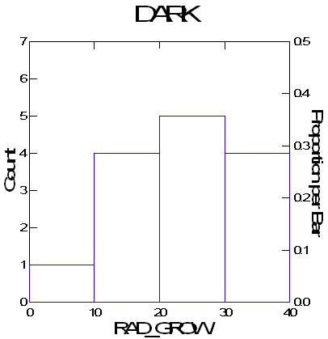

Open a new data file.
In interactive code panel, type
repeat 10 (This creates 10 empty data rows)
let N10=zrn() (This randomly generates data from a normal distribution)
repeat 100
let N100
let N100=zrn()
repeat 1000
let N1000=zrn()
let EXP=ern()
let UNIFORM=urn()

Plot each as a histogram. How does sample size affect the histogram of the normal distribution? Compare histograms of exponential, uniform, and normal distributions.
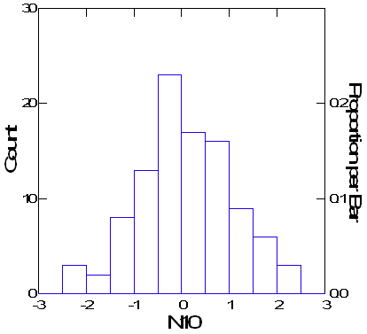
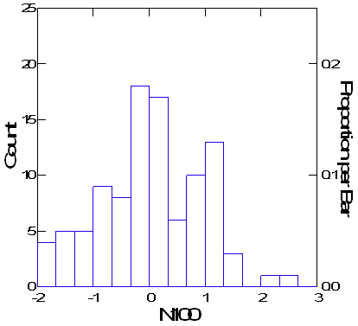
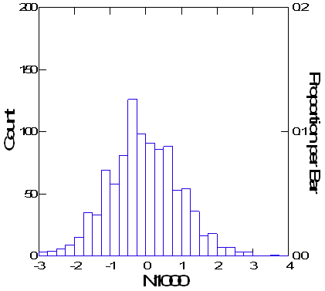
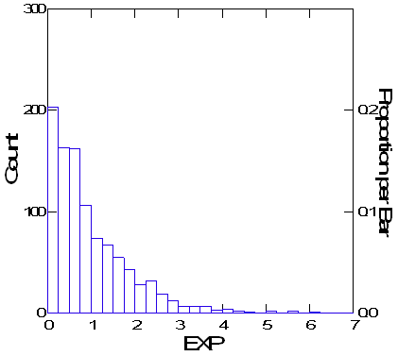

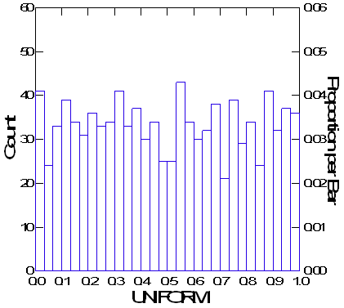

Boxplots
Initial data investigation, symmetrical distributions, outliers, variance among groups
Graph → Boxplots
X-variable: TREAT$
Y-variable: RAD_GROW
or
X-variable: RAD_GROW
Grouping variable: TREAT$

Also plot N1000, EXP, & UNIFORM

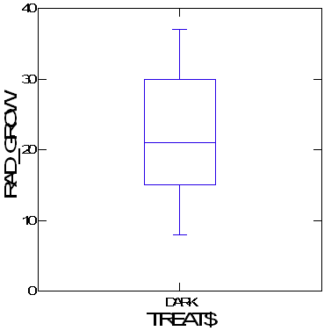
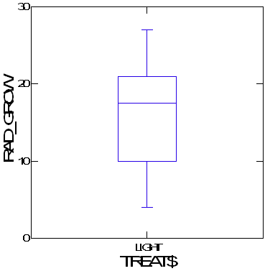
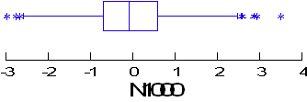
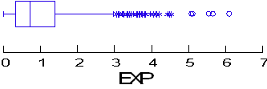
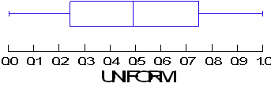

Probability Plots
Distribution assumptions for statistical tests
Graph→ Distribution Plots → Probability Plots…X-variable:N1000, EXP, UNIFORM, also RAD_GROW grouped by TREAT$.

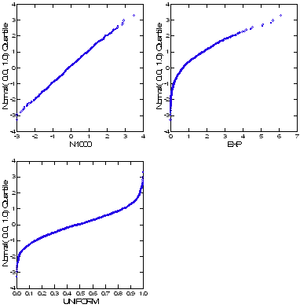

Questions
Using the file presnork.syd answer the following questions.
Are the sizes of trout normally distributed? Are there differences between the size distributions of brook trout (sp 1) and rainbow trout (sp 2)? What are the mean sizes for brook trout and rainbow trout? Could you make an estimate of ages from this data and what type of plot would you use to do so?

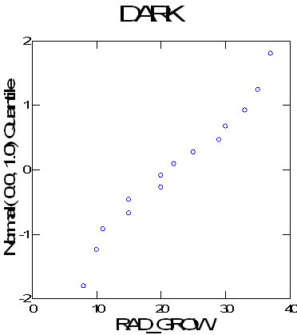
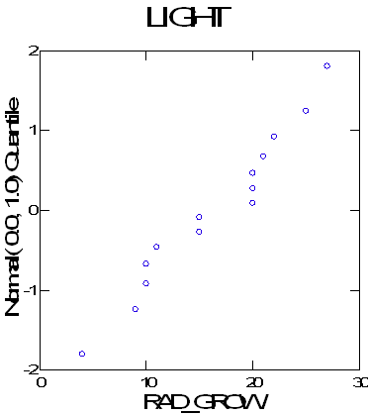

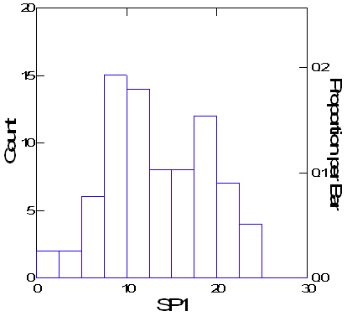
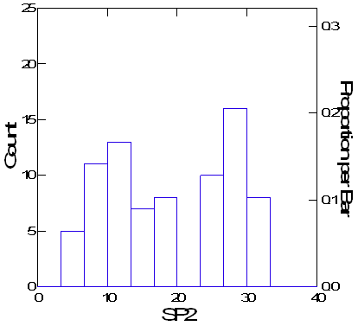
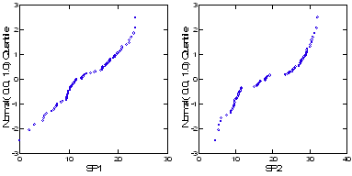

 | SP1 | SP2
Range | 23.463 | 27.672
Arithmetic Mean | 13.298 | 18.960
Standard Deviation | 5.622 | 8.665

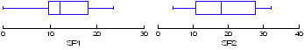

Using the file tottrhab.syd answer the following questions.
How are the focal velocities (focvel) of brook trout and rainbow trout distributed? Does a box plot show differences between these species? Are there "outside values"? How should you deal with "outside values"? What is the third quartile for rainbow trout?

Number of Variables | : | 7
Number of Cases | : | 87
SYSTAT Rectangular file C:\Users\Lab User\Desktop\tottrhab.syd,
Created data file Thu Jan 23 15:02:21 2014 containing variables:

SPECIES$ | FOCVEL | VAR(3) | VAR(4) | VAR(5) | U
SD

